How to Add and Link the Banner to Your Email Signature

Step 1: Within this Word document, select and right click a banner image and select Edit Link
*all banner images will have the default link included:
https://www.bestqualify.com/(firstname)-(lastname)/

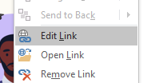

Step 2: Edit the link by adding in your first and last name in the designated spaces and click Ok
Before

After (ex. Logan Meil)

Step 3: Open New Email, click on Signature, then open Signatures…

Step 4: Choose an existing email signature to edit or create a new one

Step 5: Copy and paste a banner image (provided above) with the edited link

Step 6: Save your changes

